**12. ReactJS-HOL**

**Create a React App named “bloggerapp” in with 3 components.**

1. **Book Details**
2. **Blog Details**
3. **Course Details**

**Implement this with as many ways possible of Conditional Rendering.**

**CODE:**

**Step 1: Create the app**

npx create-react-app bloggerapp

cd bloggerapp

npm start

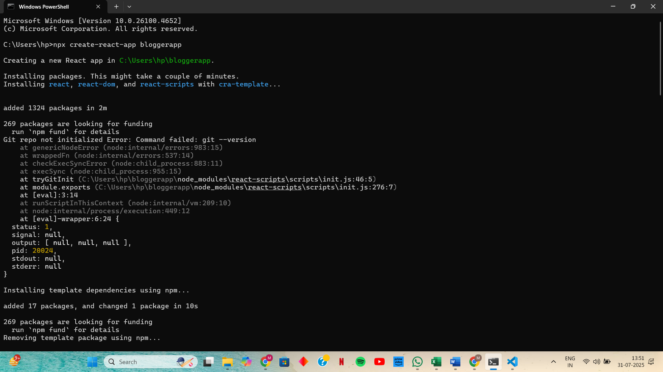

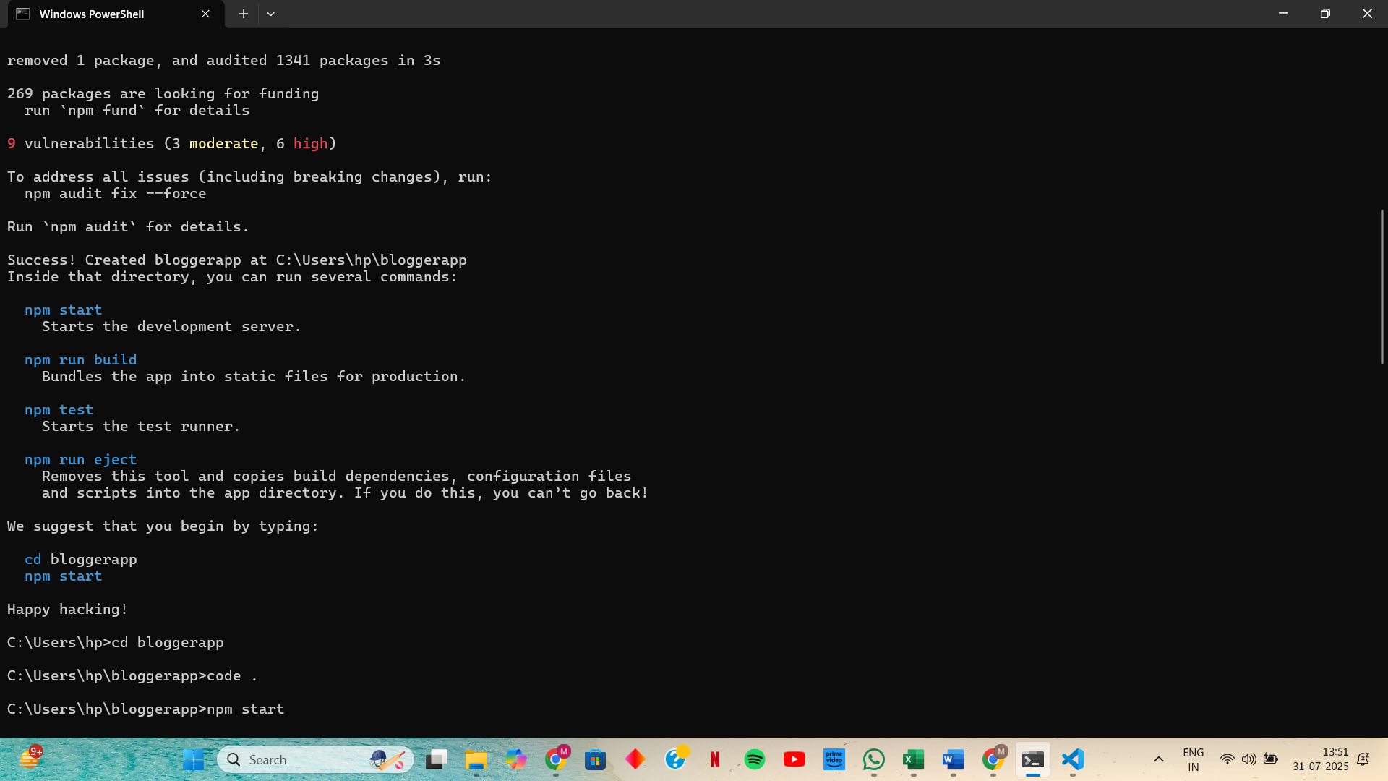

**Step 2: Create and Style BookDetails with CSS Module named BookDetails.module.css in src**

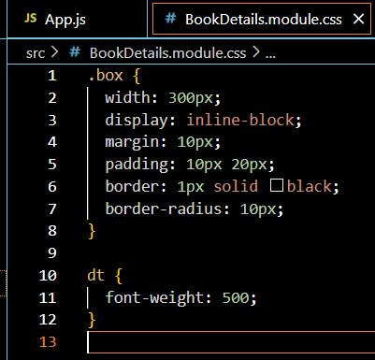

**Step 3: Create BookDetails.js in src**

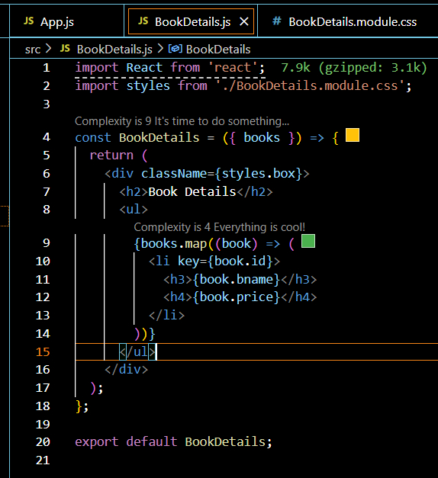

**Step 4: Create BlogDetails and CourseDetails Components named BlogDetails.js in src**

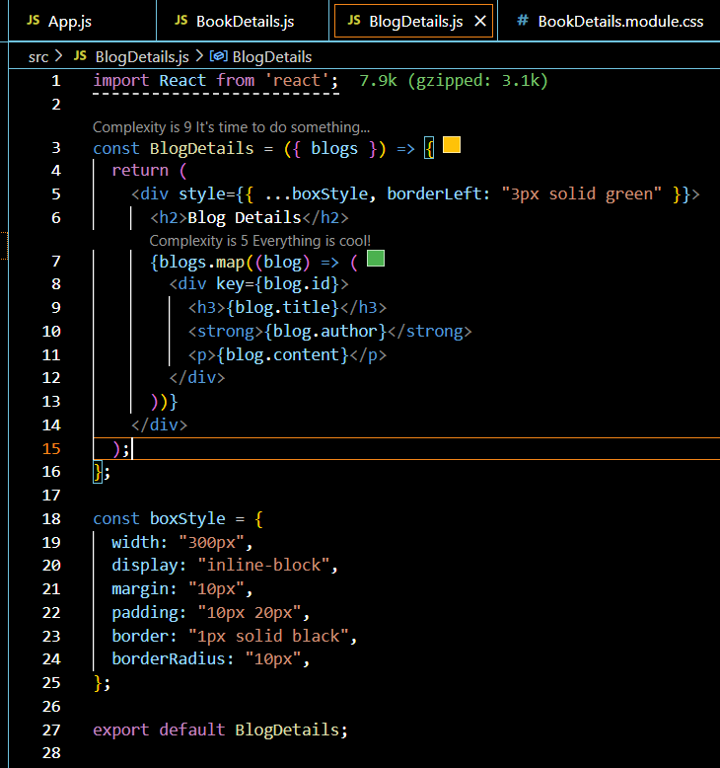

**Step 5: Create CourseDetails.js in src**

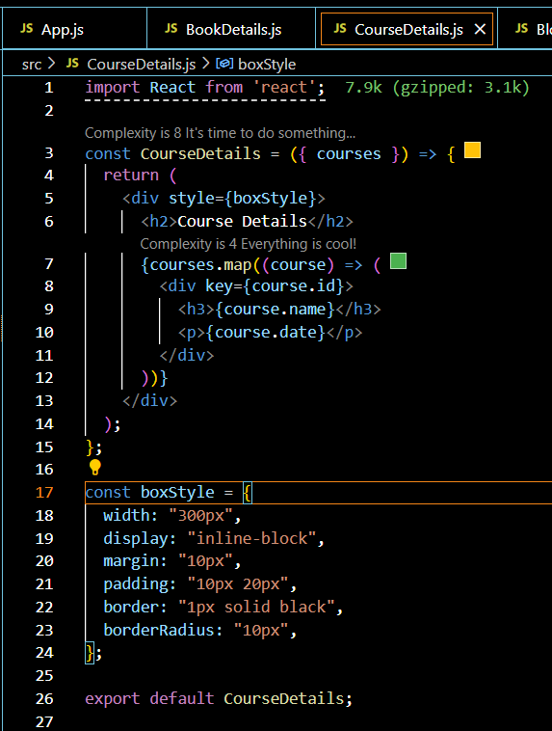

**Step 6: Main App Component with Conditional Rendering, Update App.js**

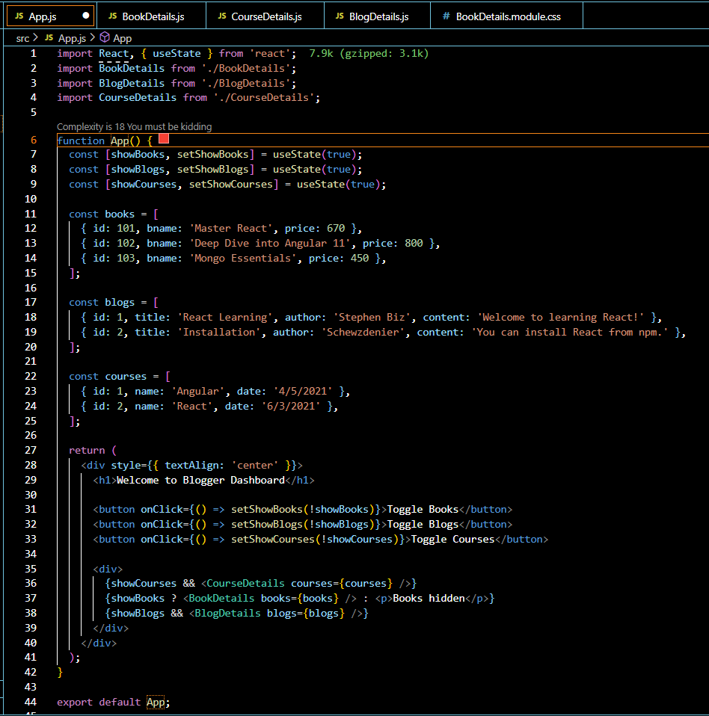

**OUTPUT:**

